Parking Guide
St Vincent Pallotti Parish Picnic & Community Event

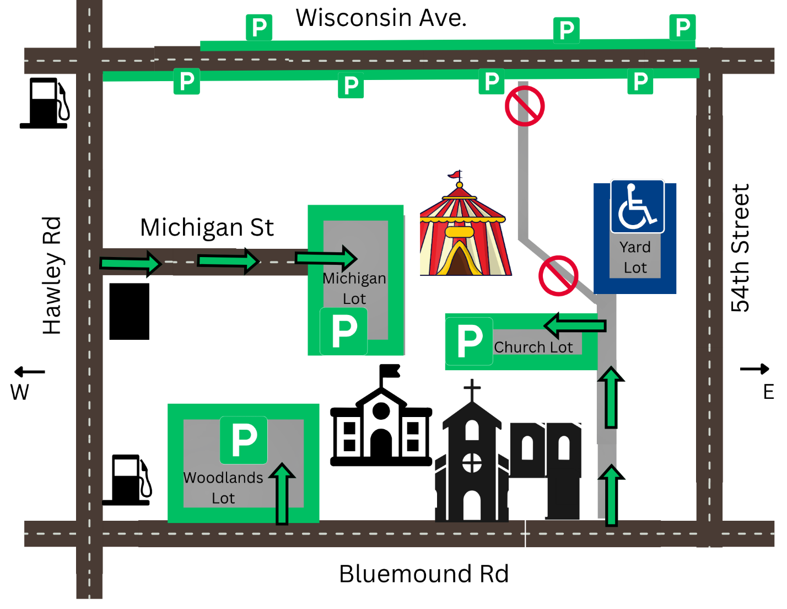
Parking is available at:
Woodlands School Lot - Located just East of the gas station at Bluemound Rd & Hawley Rd. Enter off Bluemound Road.
Michigan Lot - Located at end of W Michigan Street behind Woodlands School. Access Michigan St off of Hawley Road, midway between Bluemound Road and Wisconsin Ave.
Church Lot - Located behind Pallotti House. Enter driveway East of church off of Bluemound Road, midway between church and 54th St. Lot is on the left.
 Yard Lot (Please Reserve for Handicap or Limited Mobility Attendees) - Located East of Schoenstatt Chapel. Enter driveway East of church off of Bluemound Road, midway between church and 54th St. Lot is on the right.

